Bước 1: rails g migration add_user_id_to_friends user_id:integer:index

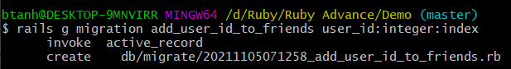

Sau đó chạy : rails db:migrate

Trong file model >friends thêm dòng

class Friend < ApplicationRecord

    belongs_to :user



end

trong file models > user.rb thêm dòng

class User < ApplicationRecord

*# Include default devise modules. Others available are:*

*# :confirmable, :lockable, :timeoutable, :trackable and :omniauthable*

  devise :database_authenticatable,

         :registerable,

         :recoverable,

         :rememberable,

         :validatable

         has_many :friends



end

trong file views>friends>_from.html.erb

  <div *class*="field form-group">

      <%= form.number_field :user_id,

      id: :friend_user_id,

      type: :hidden,

      class:"form-control",

      value:current_user.id %>

  </div>

Trong file controller>friend_controller sửa dòng cuối cùng

 def friend_params

      params.require(:friend).permit(:frist_name, :last_name, :email, :phone, :twitter, :user_id)

    end

